Alarm and Music Player
Software Design Specification

Version 1.0
Table of Contents

- INTRODUCTION 3
  - PURPOSE 3
  - SCOPE 3
  - DOCUMENT’S INTENDED AUDIENCE 3
  - OVERALL OVERVIEW 4
- SYSTEM OVERVIEW 4
  - MAJOR DESIGN ATIFACTS 4
  - FUNCTIONAL REQUIREMENT 4
  - SUPPORTING MATERIALS 4
  - DEFINITION AND ACRONYMS 4
- DESIGN CONSIDERATIONS 5
  - ASSUMPTION 5
  - CONSTRAINTS 5
  - SYSTEM ENVIRONMENT 5
  - DESIGN METHODOLOGY 5
  - ANTICIPATION DURING DEVELOPMENT 5
  - RISK AND FUTURE DESIGN CHANGES 6
- ARCHITECURAL DESIGN 6
- HIGH LEVEL DESIGN 7
- LOW LEVEL DESIGN 8
- USER INTERFACE 10
- SCENARIO 13
- LESSON LEARNED 13

- SYSTEM OVERVIEW
  - PURPOSE
This system is made to see an interaction between human and the system. The system is then equipped with clock and music player to trigger some basic interaction between human and system.
  - SCOPE
The scope of this Alarm and Music Player project is used to make the works of an alarm and music player in general that can be compiled as an interaction of human and system. The goal is how the alarm can be used and combined with the music player yet they still have each of their responsibility with their own tasks.
  - DOCUMENT’S INTENDED SOFTWARE
This document is intended for user that needs manual in using the Alarm and Music Player program and for people that need to see its specification.
  - OVERALL OVERVIEW
This system is designed for:
- Help people to listen to music with added feature such as clock, alarm, and stopwatch.
- Music player can play any song in the user’s databse (preferably MP3 format).
- Alarm and stopwatch is able to be set, reset, and snoozed according to the user’s wishes.
Low-level design (LLD) architecture of our system is the result of multiple sub-systems. Class diagram, with all the methods available is an example of LLD. Our LLD system described every function from the algorithm of our system, meanwhile our system high-level design (HLD) is a decomposition to some models or function, and representated into an interface that we made and available to use for user.
To model our system, we use major design artifatcs such as use case diagram, class diagram, sequences diagram, and state-transition diagram.

- SYSTEM OVERVIEW
  - MAJOR DESIGN ARTIFACTS
Artifacts yang utama dari sistem ini adalah:
- Use Cases
- Class Diagram
- Sequence Diagram
- State-Transition Diagram
- FUNCTIONAL REQUIREMENTS
The functional requirements are as listed here:
  - A user should be able to play song from their own computer directory
  - A user should be able to skip, return, play and pause their song
  - A user should be able to set timer for their needs
  - A user should be get the exact clock
  - a user should be able to use stopwatch
  - A user should be able to switch from clock to music player
  - The system should be able to get the clock data from the computer
  - The systen should be able to resume the song when the user pause the song
- SUPPORTING MATERIALS
Survey
We did a survey out of 45 people, divided into 3 groups where each group contains of 15 people. The groups are high-level user, intermediate-level user, and low-level user. High-level users are lecturer in UPH. Intermediate-level users are IT students in UPH. Low-level users are non-IT students in UPH (preferably, people who seldom use computer).
Books Reference
- Farre, Joyce. 2013. "Java Programming". Edisi ke-7. Boston: Cengage Learning.
- Malik, D.S. 2011. "C++ Programming: From Problem Analysis To Program Design". Edisi ke-5. Boston: Cengage Learning
- DEFINITION AND ACRONYMS
UPH : Universitas Pelita Harapan.
IT : Information Technology.
GUI : Graphic User Interface.
SDS : Software Design Specification.
SRS : Software Requirement Documentation.
SPMP : Software Project Management Plan.
STR : Software Testing Report.

- DESIGN CONSIDERATIONS
  - ASSUMPTION
Here are the list of all Assumptions and Dependencies that are made:
  - GUI is highly scored based on the how the user interface
  - Time can be used as alarm, stopwatch, timer
  - Music player can play from browsing a file
  - Music player have 5 list of songs
  - Music can be paused and play
  - All the buttons can be use properly (Next, Previous, Play, Pause, Stop)
  - CONSTRAINTS
Constraints in the system design:
- Available budget is less than Rp50.000,00.
- The system is expected to be ready in 3 months
  - SYSTEM ENVIRONMENT
Our system is made with a help of a program called NetBeans. It is based on Java language with Object Oriented Programming concept. The environment where the system is run on:
- Internet environment
- UPH environment
- Any environment for anyone who has access to our system which is accessible through our member’s computer
  - DESIGN METHODOLOGY
UML Approach Design: Use UML to describe all requirements. UML diagrams which are used : Use Case Diagram, Sequence Diagram, Activity Diagram, and State-Transition Diagram.
  - ANTICIPATION DURING DEVELOPMENT
Anticipations during development are:
- We made notes detailing improvements and changes each time the system is changed
- One of our member have a specific task to monitor changes in the system
  - RISK AND FUTURE DESIGN CHANGES
Because of the limited time and the purpose of the system, our system is made simple deliberately and it cause some risk such as:
- Bug risk
The system is coded in a hurry and not checked thoroughly, so there may be some inefficient code and this may cause some bug in the system

This system can be improved by:
- Double-checking the code and use a more efficient code.

- ARCHITECTURAL DESIGN
The architectural design have the purpose of explaining how and why the system is made that way, and also how parts of the system (sub-systems) work together as a whole and do what the system is expected be able to. Here is the flowchart of the system 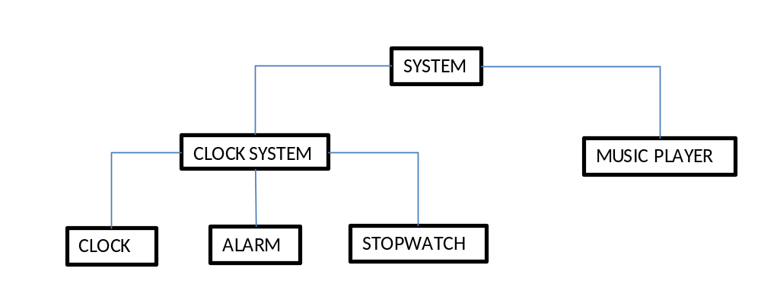
Architecture for System

Architecture Structure from Alarm and Music Player System
Software Structure | Units | Relevance in System Development
Conceptual | Functions | The system is able to show what time it is, set an alarm, and function as a stopwatch. The system should also be able to play music form the user’s directory
Physical | Hardware | Hardware requirements is a PC with Java installed on it

- HIGH LEVEL DESIGN
Our system used a simple architecture where the window is divided into 2 parts (Clock and Music Player system). The purpose of this system is to see an interaction between human and the system.
The system is developed by using:
- Programming language : Java. The system is made entirely with Java and the library used is simple enough.
- Software Development Platform used in the development is NetBeans IDE 7.4 on Windows operating system.

Database Design
Songs
This database of the system is only consisted of the songs that the users uploaded. Because of this nature, the database is pretty much only hold one type of file

Field | Type
Song | String
song1 | char(35)
song2 | char(35)
song3 | char(35)
With information as follow:
- Song is a primary key for the table.
- song1 is the content of the first line of field Song
- song2 is the content of the second line of field Song
- song3 is the content of the third line of field Song

- LOW LEVEL DESIGN
Here are some of the main algorithm thar are used in the system:
public MainGUI() {
initComponents();

helpFrame.setVisible(false);

clockTitle.setVisible(true);
MP3Title.setVisible(true);

clockLabel.setVisible(true);
stopAlarm.setVisible(false);
hourInAlarm.setVisible(false);
colonSymbol.setVisible(false);
minuteInAlarm.setVisible(false);
backgroundHourDisplay.setVisible(false);
backgroundMinuteDisplay.setVisible(false);
plusHourButton.setVisible(false);
plusMinuteButton.setVisible(false);
minusHourButton.setVisible(false);
minusMinuteButton.setVisible(false);
timeRemaining.setVisible(false);
setAlarm.setVisible(false);
clock_button.setIcon(new ImageIcon(getClass().getResource("clock.png")));

stopwatchLabel.setVisible(false);
lapStopwatchDisplay.setVisible(false);
startStopwatch.setVisible(false);
stopStopwatch.setVisible(false);
lapStopwatch.setVisible(false);
resetStopwatch.setVisible(false);
resetStopwatch.setEnabled(false);
pause_button.setVisible(false);

hourInAlarm.setText(hourDisplay);
minuteInAlarm.setText(minuteDisplay);

stopwatchLabel.setText(stopwatchDisplay);

//shortcutMP3.setEnabled(false);
shortcutJam.setEnabled(true);

new Thread()
{
@Override
public void run()
{
while(true)
{
cal = new GregorianCalendar();
hour = cal.get(Calendar.HOUR);
min = cal.get(Calendar.MINUTE);
sec = cal.get(Calendar.SECOND);
AM_PM = cal.get(Calendar.AM_PM);

if(AM_PM == 1)
{
hour = hour + 12;
}

String time = String.format("%02d : %02d : %02d", hour, min, sec);

clockLabel.setText(time);
}
}
}.start();
}
This part of the code shows how the GUI of the system is arranged.

- USER INTERFACE
      - HOME/CLOCK
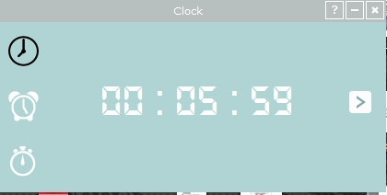

      - ALARM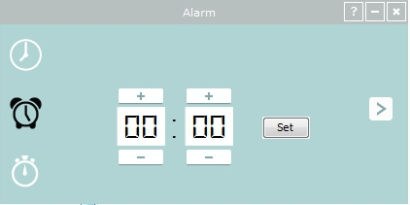
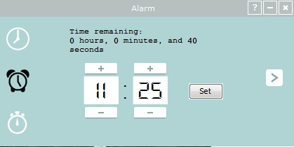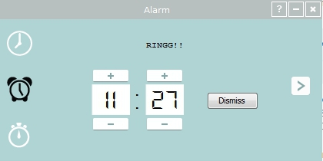

      - STOPWWATCH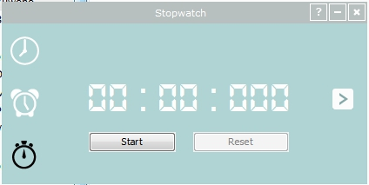
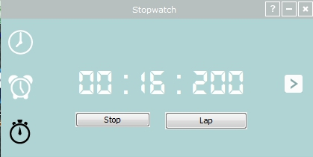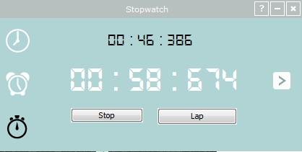

      - MUSIC PLAYER
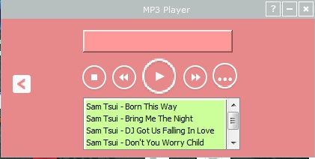
- SCENARIOS
Actor:
User
Role:
User : Play and stop music, select next or previous track, browse music and change directory, set alarm, stop and dismiss alarm, start stopwatch, and reset and record stopwatch.
Assumption and dependencies:
- User sets alarm and then stops it when it rings
The main actor in this scenario is obviously the user since there is no other actor. When the user set the alarm, the system will calculate how much time is left until the alarm goes off and show the remaining time on the windows. It will ring when the time is up and the user is able to dismiss it to stop the alarm from ringing.
- User plays and stops music
The user can upload up to 5 songs from his or her directory to the system. Once the songs are uploaded, it can be played on the system. Also, the user can stop it at anytime he or she wants.

- LESSON LEARNED
Lessons learned in the making of this SPS are:
- Software planning is an integral part of software development
- It doesn’t matter how big or small a system is, it still need to be specified especially to the user
- Specification of a software is not something to be underestimated. It may be useful for future development

